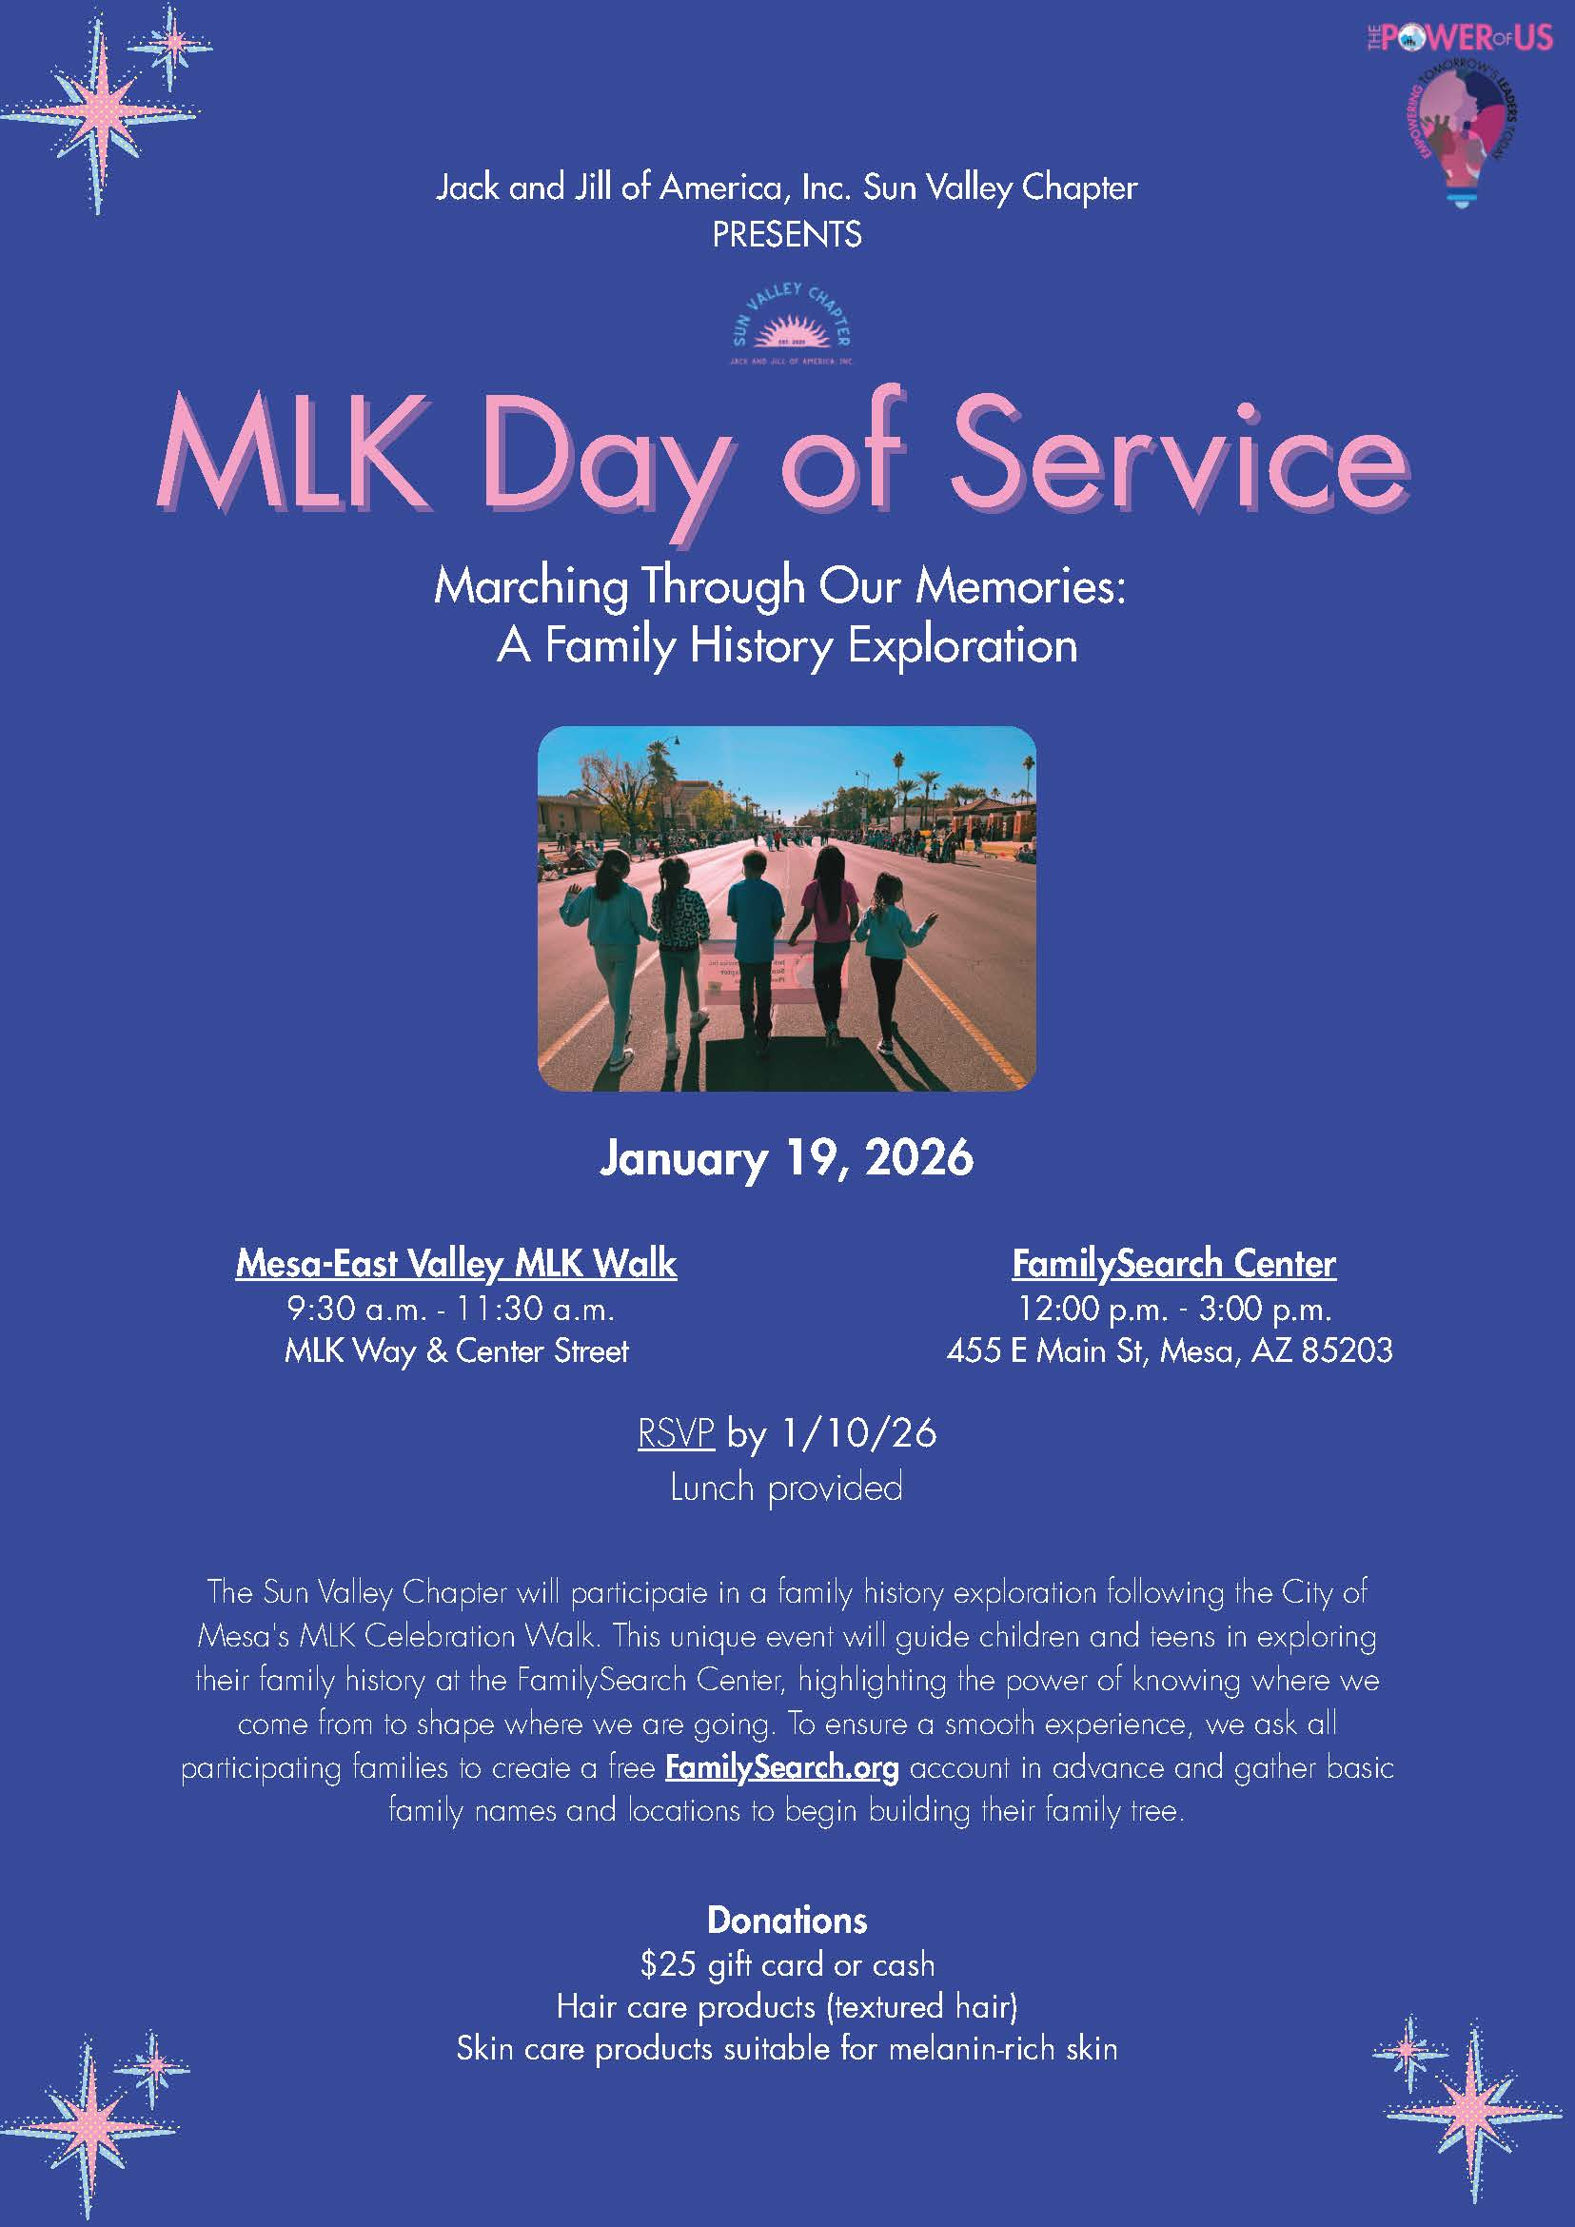
The Sun Valley Chapter of Jack and Jill of America, Inc. will be participating in the 2026 MLK Day of Service – Marching Through Our Memories: A Family History Exploration which is taking place on Monday, January 19, 2026, immediately following the City of Mesa MLK Celebration Walk.

Hosted at the Mesa Temple FamilySearch Center, this program is designed to connect our children and families to the legacy of Dr. Martin Luther King Jr. by exploring the power of our own family stories. Guided by Jack and Jill's five national programmatic thrusts, we'll blend storytelling, technology, civic reflection, and genealogical research into a meaningful experience for you and your children.

Each grade group will engage in tailored, hands-on activities, from family tree crafts and world maps to oral history interviews and discussions on public policy within this beautiful facility. With guidance from FamilySearch volunteers and potential support from the Black Family Genealogy & History Society of Arizona, participants will gain tools to begin or expand their personal family history using the FamilySearch platform.

To help us prepare, please do the following:

Create a FamilySearch.org account for yourself before the event. This will help maximize our time together.

Write down usernames and passwords to bring with you

Begin collecting names, dates, and locations for grandparents/great-grandparents

Watch for additional prep tools (social stories, worksheets, and handouts)

In addition, FamilySearch offers powerful technology tools that help families preserve and reconnect with cherished memories stored on legacy media, even formats that are no longer widely used, such as VHS tapes, audio cassettes, film reels, and undeveloped film. This means that treasured audio recordings of relatives, home movies, slides, and photographs, and even fragile film reels, can be safeguarded for future generations rather than lost to time or obsolete playback equipment.

This event is more than a workshop. It's a celebration of identity, culture, and the multigenerational strength within our families. By honoring our roots, our children can better understand who they are, where they come from, and how uniquely positioned they are to lead with purpose.

